Prerequisite: Install OpenSSL

* Download Win32 OpenSSL Light from here: <https://slproweb.com/products/Win32OpenSSL.html>
* Install to default location

Step 1: Generate certificate signing request and public key

* Go to <https://certificatetools.com/>
* Follow this example:

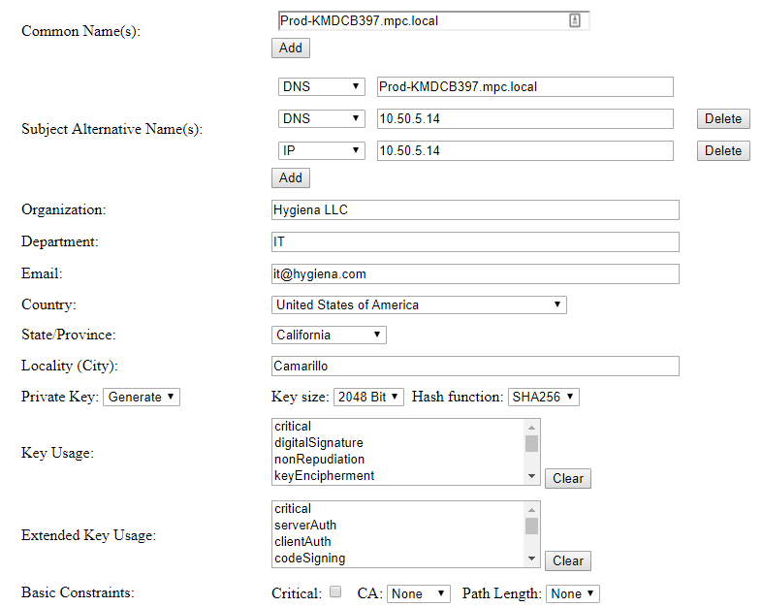

* Click Submit
* Expand Download section
* Download Private Key and Certificate Request
* Open csr.txt, select all, and copy

Step 2: Submit certificate request

* Log into (Cert authority server)
* Paste certificate request into Saved Request field
* Change Certificate Template to Web Server
* Click Submit
* Download DER encoded certificate

Step 3: Generate certificate

* Run the following command:
* CD to C:\OpenSSL-Win32\bin:>

openssl pkcs12 -export -in C:\Users\wboatman\Downloads\certnew.cer -inkey C:\Users\wboatman\Downloads\key.txt -out C:\Users\wboatman\Desktop\merged.pfx